**MY WILD CAMPING THOUGHTS**

Much of this is from messages I’ve written in answer to (sometimes very specific) questions

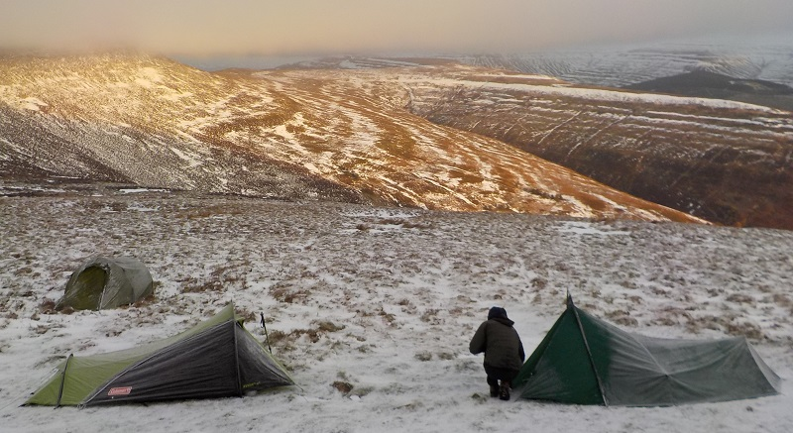

By Paul Ridealgh

Version 2 29th July 2019

1. Where and when

2. Equipment

3. Food

4. Kit list

5. Other people’s comments

**1. Where and when**

This was on the Lake District National Park Authority Website....

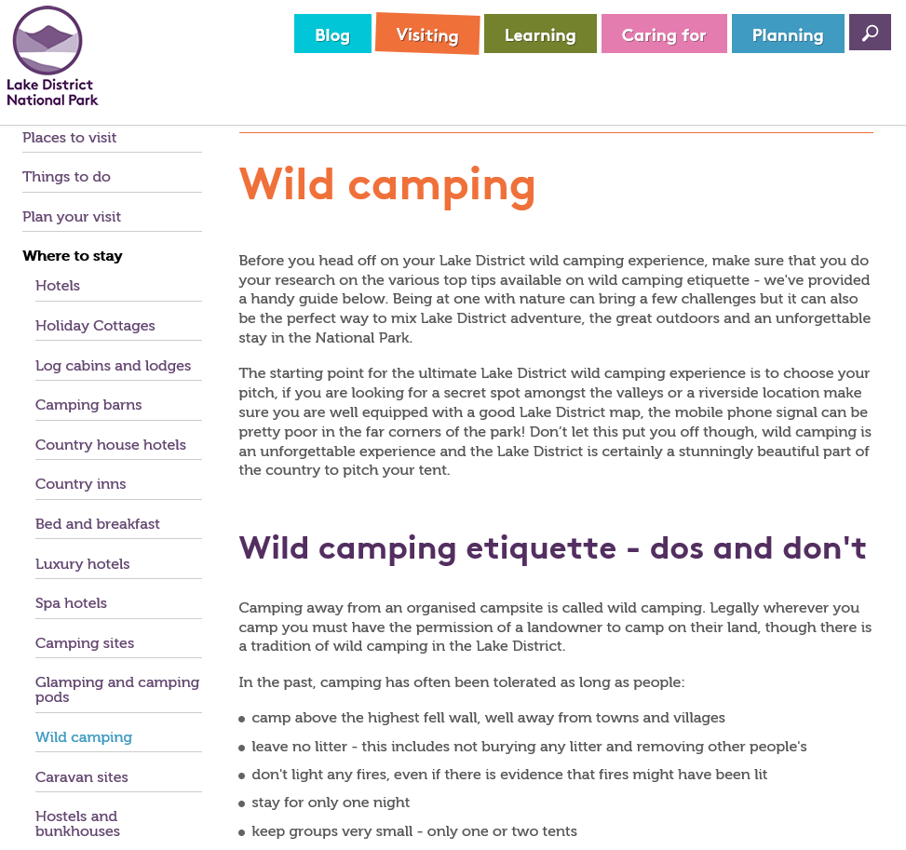

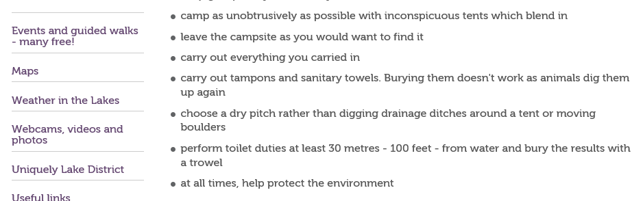

**The guidance from other English and Welsh National Parks is similar**; except for Dartmoor, where the National Park website provides a map, showing areas where wild camping is permitted.

Unless the land owner’s permission is obtained, we have no right to camp, and must immediately pack up and move on, if requested to by the land owner or his agent. I have only been moved on once, which was more than 40 years ago on Dartmoor; fortunately the farmer next door gave us permission to camp on his land. On another occasion, soon after we had left our camping area, a farmer got to it, saw us a few hundred yards away, he searched the camp area thoroughly and went back down the mountain. So long as we follow the Lake District etiquette, and are invisible, out of sight, pitch after dusk and depart by dawn and are a very small group with very few tents, we are unlikely to be noticed and therefore unlikely to be disturbed.

**The Scottish Access Code says**: Access rights extend to wild camping. This type of camping is lightweight, done in small numbers and only for two or three nights in any one place. You can camp in this way wherever access rights apply, but help to avoid causing problems for local people and land managers by not camping in enclosed fields of crops or farm animals and by keeping well away from buildings, roads or historic structures. Take extra care to avoid disturbing deer stalking or grouse shooting. If you wish to camp close to a house or building, seek the owner's permission. Leave no trace.

Before wild camping in Scotland, read the Mountaineering Scotland website sections relevant to wild camping, including taking account of etiquette relating to stalking and shooting seasons. There are many areas (such as around Loch Lomond) where wild camping is not permitted (or is only permitted at certain times); do not camp in those areas when not permitted.

**Places to Avoid**

**To stay alive**, do not camp in places where lightning is likely to strike; if there is any risk of lightning. Learn how to determine which areas are in lightning shadow and where lightning is likely to track; to work out where will be safe. Imagine rolling a 1000 metre diameter ball around the landscape, areas the ball cannot touch may be in lightning shadow, anything it can touch (summits, ridges, plateau’s plains etc.) are high risk. The lightning is trying to discharge itself to earth; rock isn’t a very good conductor of electricity, so it will try to “track along something that is, such as water or metal, so do not be close to streams, pylons, metal pipes and fences etc. If hair starts standing on end, skin tingles or there is humming / buzzing, you are at very high risk and need to immediately move.

Do not camp on any horizon or any path and try to be out of sight from all paths (you are trying to be invisible).

Do not camp in line of site of any occupied building (unless they have given you permission).

Do not camp in any hollow that could flood,flood plain, bog or (part time) stream/river bed or tidal areas.

Do not camp where you could be at risk of falling rocks, trees etc.

**2. Equipment - Tents**

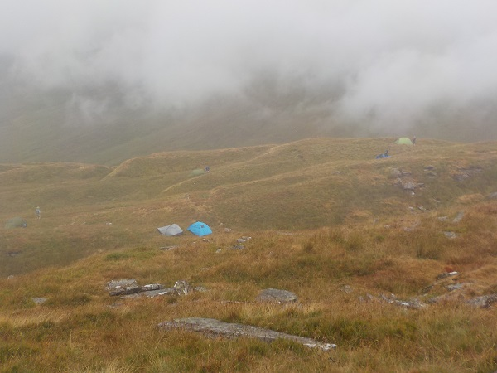

Choose an inconspicuous colour (dark green is good), how many of the 7 tents can you see?

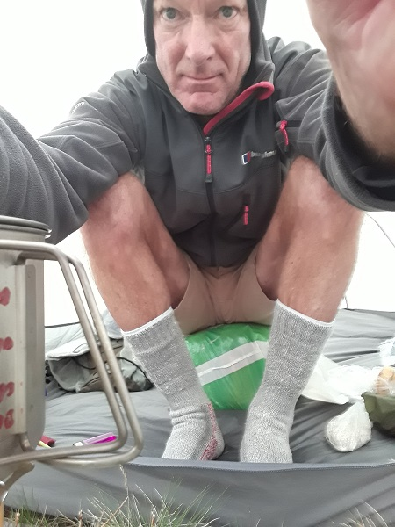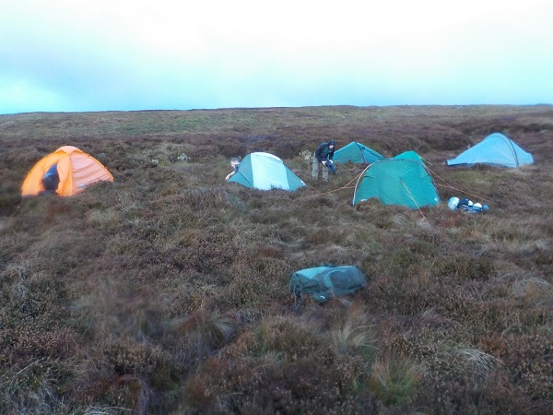

Sitting in tent, on sleeping Is your tent easy to pitch, on the normally rough ground?

bag (in compression sack).

In my view, the best tent for wild camping (regardless of price) is the Force Ten FT Xenon UL 2. It’s what I and several other people have recently bought. It’s the optimum compromise between being light, spacious, small when packed, and easy to pitch on rough ground. It’s also just possible to close the outer tent to get waterproofs off, before going into the inner tent (with most small tents, you have a choice of going in wearing waterproofs and soaking everything or taking your waterproofs off and getting soaked before going in). There’s also enough height to be able to sit on your rolled up sleeping bag at the front of the inner tent while operating the stove in the outer tent (which is very dangerous and shouldn’t be done; read more in “stoves), which is much nicer, and safer than trying to cook when lying down. Only buy a tent which pitches flysheet first (otherwise your inner tent is already soaked before you get in it. Tents with only 2 poles, which flex in the breeze are usually easier to pitch on rough ground than ones that have several poles that lock together to provide rigidity. You’ll now realize I’m very biased, however I couldn’t find anything better, even at 3 times the price. On-line they seem to be available at about £250 - £300 new. Don’t buy a tent that has been outside on display for a whole summer or had lots of people going into it with sharp shoes on, destroying the groundsheet. Note that the “2+” version has a bigger area in the outer tent, but slightly bigger, heavier and requiring more space to pitch).

**Bivvy Bags and Tarps**

I’ve slept in survival bags, both with and without a sleeping bag, which usually results in getting rather wet. With a good quality breathable bivvy bag, plus tarp, plus lines and pegs, being as heavy and expensive as a tent; I’m intending to stick to what I believe is the greater protection, convenience and comfort of a tent. I suggest you talk to bivvy bag users about the benefits of their accommodation. Also consider how, when wet and windy, you will transition from being dry and comfortable hiking, through preparing and eating your dinner, to dry and comfortable inside your bivvy bag.

**Sleeping Mats**

Foam roll up sleeping mats are very good at insulating, very robust, very cheap, the only weakness is their bulk; however it is ok to have it strapped to the base of your rucksack.

If you want to spend 20 times more, you can get an inflatable mat which is reasonably good and a lot more compact. Self-inflating mats are too heavy and too bulky.

**Sleeping Bags**

I bought a good quality SYNTHETIC 4 season sleeping bag for winter use 30 years ago, which is still serving me excellently. Don't buy down for use in Britain, if it gets wet, you won't be able to get warm that night and it's likely wrecked. If you get synthetic, you can wring most of the water out of it and sleep in some warmth. If you wear much of your clothing in the sleeping bag, you can use a lighter bag. It’s well worth wearing a warm hat whilst sleeping. If you are wearing much of your clothing in the sleeping bag, it may be worth taking a small inflatable pillow (mentioned later).

A light weight sleeping bag is fine in the summer in the UK.

**Rucksacks**

My rucksack is 65 litres, with the above tent, sleeping bag in a compression sack and a compact inflatable sleeping mat, everything fits nicely inside. I wouldn’t get a smaller one and think 80 litres is too big. Put everything that will go into the rucksack in individual, sealed plastic bags.

**Footwear**

Hiking boots are very much a personal choice, depending on a comfortable fit. I’ve got more expensive boots, but use my Scarpa Terra GTX for wild camps (and Everest Base Camp), because they are very light, comfortable, good tread, vibram soles, good ankle protection and are waterproof for about 18 months. They can be kept waterproof after that by regularly applying Nikwax (or similar). Try the Scarpa, then buy a similar boot from whichever brand has the best fit and HAS A VIBRAM SOLE. I expect you’ll get a good pair of boots for £130 to £180. If your boot laces are long enough, there’s many ways of lacing boots to have them loose in some areas, tight in others, holding your foot down and/or holding your foot back.

**Walking Poles**

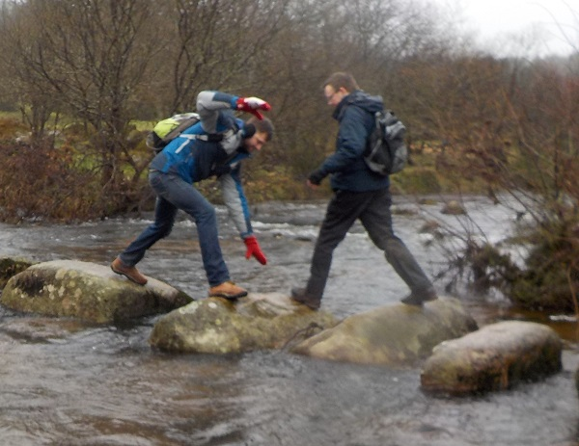 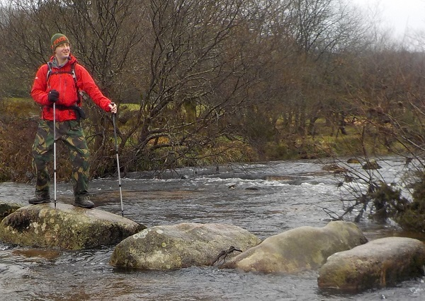

A pair of walking poles make you so much more secure, giving you a minimum of 3 points of contact (rather than 1) when crossing stepping stones, and essential for crossing bogs in wet weather; that you need them on Dartmoor. They also make it much easier to maintain balance when wind gusts hitting your big rucksack are trying to spin you round and knock you down. They also reduce the load on your knees going downhill and give you a good upper body workout.

Alp Kit carbon fibre walking poles are very good (but not indestructible) and very good value for money, but you can get heavier poles a lot cheaper.

**Waterproofs and Gaiters**

Little specific to wild camping. In summer, you may choose to bring a rather lighter hooded waterproof jacket than your hard shell jacket designed for Scottish winter conditions. If it’s raining and you’ve got bare legs (whether or not you’re wearing gaiters), water will run down your legs and get your socks wet, not an issue on a day hike, but you probably won’t want wet feet for several days.

**Sun Protection**

Even in British extreme summer conditions, as well as Factor 50 sunscreen, it’s well worth having clothing that can shade all of your body from the sun; including wide brimmed sun hat, long sleeve shirt, long trousers and sun glasses.

**Cooking Equipment** –Stoves

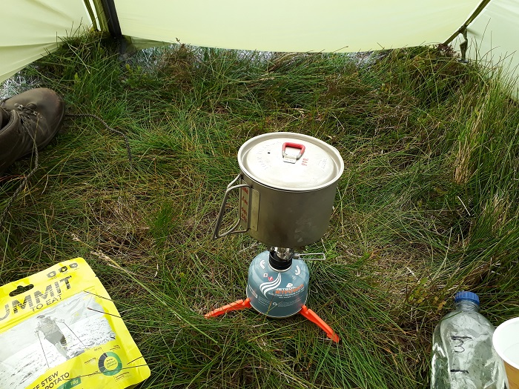 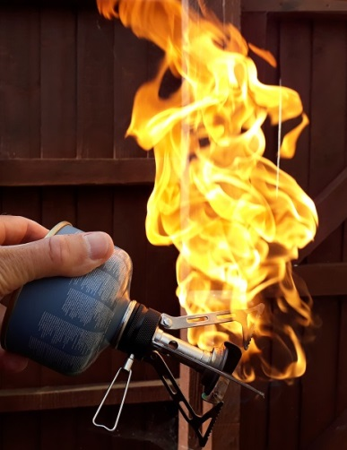 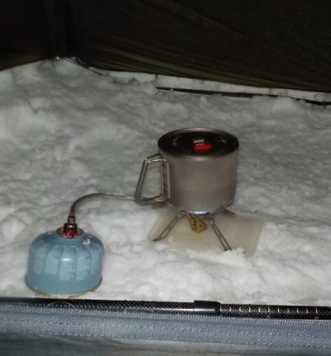

Most tiny screw-on stoves are excellent for spring to autumn use, with a 70% butane/30% propane gas cylinder (mine’s the £7 Go-Outdoors OEX XT-2 Intensity, shown in the left pic). Absolutely never use them in the inner tent; also don’t use them in the porch (shown). If the pot is not on the burner, the flame will set the tent on fire; if the burner falls over, it will flare (middle pic) setting the tent on fire. If you are unwise enough to attempt (and probably fail) to cook in the porch, be certain to use a gas canister stand, and have a very sharp knife next to you, so you can slash the side of the tent to escape. Find a very sheltered place, far from anything combustible to cook. A Gas Canister Stand will make the stove much more stable and safe. It’s worth purchasing (or making) a windshield to dramatically reduce heating time and gas consumed. If you’re going to do a lot of camping, you may want to get a Jetboil, MSR windburner or similar stove system.

For winter use (see right pic) a gas stove with a vaporising tube next to the burner is useful. If it is fed by a tube from the gas cylinder, it is likely to be much more stable than stoves with the burner screwed onto the top of the cylinder. The vapourising tube will vaporise the gas, ensuring the flame is powerful, even a few degrees below zero. Some stoves of this type should (and some should not) have the gas cylinder upside down; make sure you read and follow the manufacturer’s instructions. Some stoves of this type will not flare if knocked over, check the manufacturer’s safety instructions.

Gas cylinders cool down considerably when stoves are in use, so gas stoves often do not perform as well as expected in cold conditions. Using a gas cylinder with higher than 30% propane will help, also putting the cylinder in an inside pocket for a while before using the stove an also help. Do not be tempted to hold the cylinder of a stove with a burner screwed directly on top whilst using it to avoid burning yourself or tipping boiling water onto yourself. You sometimes can hold the cylinder of a stove which has a tube feeding gas to the burner.

Solid fuel, methylated spirit, petrol and paraffin stoves are also available, however I believe the gas stoves covered above are better.

**Cooking Equipment** –the rest of it

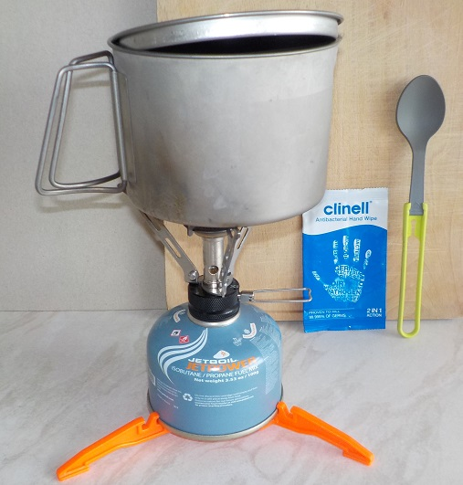

You can get a perfectly good 1 litre aluminium pan with handle and lid for £7, I suggest you start with it. If you love wild camping, you can later spend £50 on the pictured MSR Titanium 850ml kettle. You can use a porridge pot as your mug and bowl; also a disposable plastic spoon (light, effective and comes free with your chipshop curry), or spend a fortune on the pictured folding spoon.

Blue clinell wipes are designed for giving bed baths, so are fine on sensitive skin, for long term contact. They have a lot of liquid so you can wash (not just disinfect) and kill 99.999% of the germs you’d otherwise add to your meal.

**Equipment** –Other Random Stuff

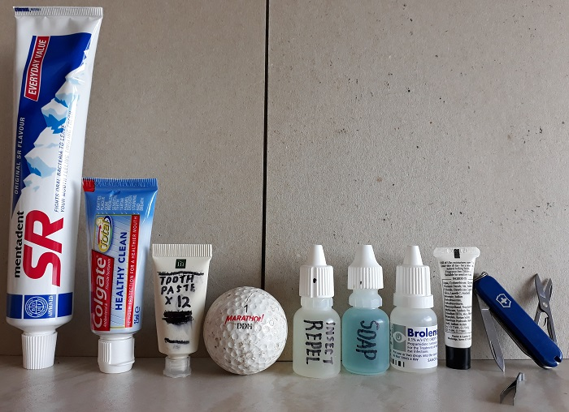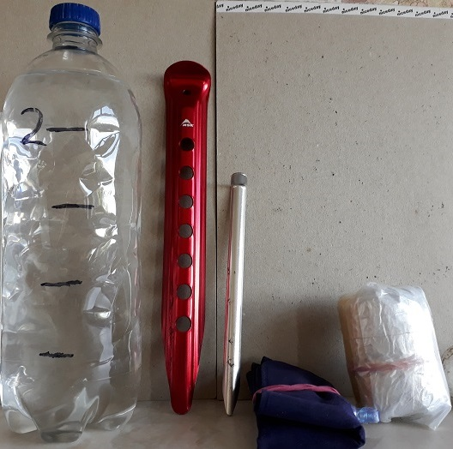

As a novice wild camper, your rucksack containing everything except water, should not weigh more than 14kg for a weekend event. Towards achieving 14kg, do not bring anything you won’t use. Preferably put just enough toothpaste into a (cleaned out) miniature sample bottle; failing that, squeeze just enough toothpaste into an empty flight hand luggage toothpaste tube.

Eye drop bottles make good liquids bottles.

Life Venture blue soap can be used as shower gel, washing up liquid, for laundry etc.

You can get very small penknives which include scissors and tweezers.

The photo also shows a golf ball (for scale) an inflatable pillow (with pink elastic band), a survival bag, normal tent peg and a blizzard tent peg ( which is light and good for digging toilet holes (use in conjunction with toilet roll and hand sanitizer), also very useful in sand and snow).

A tiny 40cm X 40cm travel towel is excellent as a handkerchief, flannel, towel, rinses out easily and dries quickly hanging from a rucksack.

https://www.mountainwarehouse.com/clip-towel-small-40x40cm-p13334.aspx/teal/

For minimum weight, plus durability, plus being collapsible, you won’t get much better than a supermarket 1 litre own-brand 20p lemonade bottle. Being one litre, it’s the right size to take 1 water purification tablet. Number the bottles so you’ll know which one is still going through the water purification process. Many porridge pots and drink sachets need 200ml of water and many ready meals 400ml. By marking 200ml increments on the bottle, you’ll avoid boiling too little/much water.

Water purification tablets are my preferred way of getting safe drinking water. Follow the manufacturer’s instructions, often you need to wait 30 mins. One supplier is Oasis (http://www.oasiswaterpurification.com/ ). Oasis travel tablets are available in both 8.5mgNaDCC and 17mg NaDCC sizes (military and emergency dosing are both done according to the World Health Organisation Guideline of 5ppm of Chlorine, followed by waiting 30 minutes. This is achieved by using one 8.5mg NaDCC tablet per litre of water).

If you are considering buying a water filter, read the specifications of filters higher up the range, to see what things they capture, that isn’t mentioned on the packaging of the cheaper models (usually viruses, sometimes ineffective with cloudy water).

I’ve tried several types of filter, those that filter out viruses require so much effort and require such clean water (to avoid very rapid clogging) that I haven’t found them to be reasonably viable.

Water that has been through filters that don’t take out viruses, needs to be treated with purification tablets anyway. If the water’s clear, there’s little reason to filter it, if it’s cloudy, it will quickly block your filter. I try to save my clearest water for drinking, and slightly cloudy for cooking (and have now stopped carrying a filter in wet conditions in the UK). Whatever that’s purified and no more than slightly cloudy, that won’t sink or float, I’ll drink. However, cloudy (turbid) water can cause stomach/digestive tract upsets, so it is wise to carry a filter (e.g. the MSR TrailShot) if there’s a risk that you’ll need use cloudy water. I’ve had a ceramic filter block in less than 3 litres and the MSR trailshot in less than 10 litres, taking water from storm flooded streams in the Brecon Beacons. Scraping off ceramic filters and backflushing the trailshot keeps them limping along for a while. Some filters, with a dangling pick up hose (such as the MSR TrailShot) make it easier to get the water out of a very shallow stream or pool and into your bottle.

**Equipment** –When life becomes a little more challenging

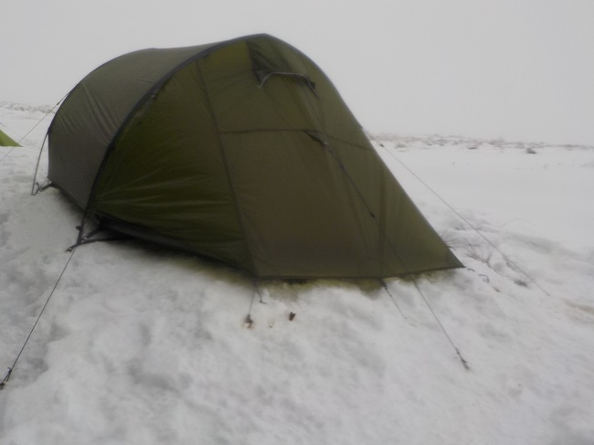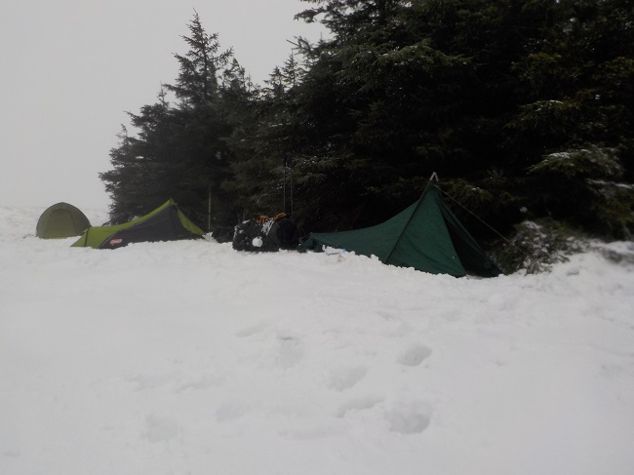

Gain experience, preferably with others, relatively close to civilisation, before attempting remote locations or extreme weather. Have equipment that is fit for purpose; a summer tent will very quickly be destroyed, when unsheltered in storm conditions. A specialist winter tent will be unbearable in summer conditions, with a choice of being eaten alive by mosquitoes or with very little ventilation.

Unless keeping out spindrift (very fine wind blown snow, rain or sand)), it is usually best to have the maximum ventilation through the tent, to prevent condensation.

In stormy conditions, find the safest, most sheltered camp location. Try to point the back or front of the tent into the wind. For maximum effectiveness, have your guy lines at nearly maximum extension. Consider releasing or removing the tent poles, while keeping the tent pegged down, so that the tent survives. If bad weather is a possibility, it could be worth carrying 2 (or 4) Blizzard pegs. In sand, consider replacing strategic tent pegs with buried sticks or rocks. In snow, stand where you want to place each peg, wait for a minute and then press the peg into the consolidated snow.

**3. Food**

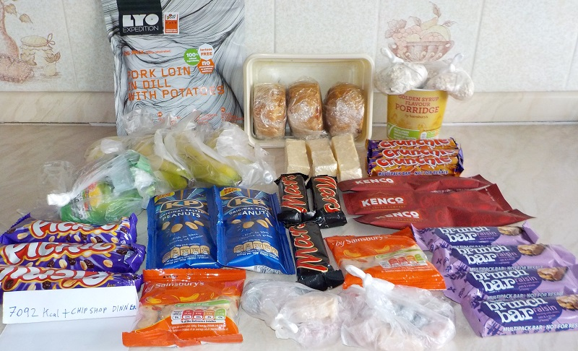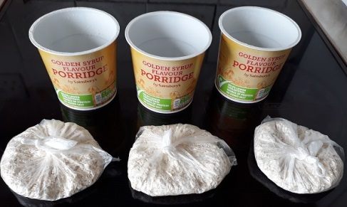

Right pic – It’s just possible to get the contents of 4 porridge pots into one pot. If all portions are in separate bags, you can use the pot as your coffee mug before consuming any porridge. Golden syrup favour has more calories than the others. A lot of calories for a miniscule weight.

Left pic – After a Friday evening chip shop supper, 7000 calories gets me over 42km and 1400 metres of ascent by Sunday afternoon, with a little to spare, in case of unforeseen happenings (all the food is in the photo.)

**Chilled foods** – if put in the freezer for a couple of days, tightly wrapped in spare clothing, in a plastic bag and then kept in the centre of a rucksack can still be cool by Sunday lunchtime. Pork pies, sausage rolls, cheese etc. are very energy dense and cope well with being deep frozen.

**Fresh food** – with care, bananas survive well and at nearly 100 calories per 100 grams provide a decent amount of energy. Although apples are more robust, with only 50 calories per 100g, I don’t carry them.

**What else**?

- Nuts are very robust and don’t melt when warm or leak; with Cashew nuts at nearly 600 calories per 100g and Brazil nuts at nearly 700 calories per 100g, nuts are the superfood for wild camping.

- Porridge pots are excellent; Breakfast bars are good.

- Kendal mint cake, Jelly babies, fruit pastilles etc. survive heat better than chocolate bars

- Chocolate bars melt when warm.

**What about Dinner**

Sealed, dehydrated meals are what nearly everyone eats now, very easy to prepare, no washing up and you choose the number of calories. <https://basecampfood.com/> has a massive range of meals and 15% discount for ODL members spending more than £20.

Boil in the bag meals are cheaper, ok for one night, but too heavy to use for longer, as well as requiring you to carry a much bigger pan, use more fuel and your coffee tastes strange when using the water you used to boil the bag.

Tortellini is another viable option, which only requires a couple of minutes of simmering.

All in one coffee sachets are a way of getting appropriately milky/sweet coffee or chocolate drink with an acceptable taste and plenty of calories.

**Calories per 100g (before rehydrating)**

Apple 50

Banana 100

Mini Melton Mowbray (50g) pork pie 407

Cheshire Cheese 343

Golden Syrup Porridge Pot 366

LYO pork Loin (dehydrated) 410

Expedition Foods Beef Hotpot (dh) 505

Cadburys Brunch Bar Raisin 428

Mars Bar 448

Crunchie 466

Picnic Bar 479

Jelly Babies 330

Fruit Pastilles 352

Salted Peanuts 614

Mixed Nuts 650

Brazil Nuts 690

Kenko Latte Coffee Sachet 397

**Take a look at my food selection list (with the kit list) to see my food choices.**

**4. Kit Lists**

These are my personal lists, yours will be different, but mine should give you some clues.

Think of your personal medical needs, allergies, dietary preferences etc.

My luxuries usually include an inflatable pillow and pump action sunscreen dispenser, you will have different priorities.

I will change many of the items e.g. in winter I may replace summer boots with winter boots.

**My personal list to select from, including summer and winter items**



**My personal food selection list** - many items changed to suit event



**5. Other people’s comments**

No comments that I’ve chosen to add yet – many people must think that their tent and water purification methods etc.are better than mine?